AIR QUALITY MONITORING

TEAM MEMBER

71772114312 : SUGANKARTHICK R

PHASE -1 DOCUMENT SUBMISSION

# PROJECT DEFINITION

The aim of the project is to design and implement a system that can measure and report the concentration of various air pollutants in a given area, using low-cost sensors and satellite data. The system will consist of the following components:

* A network of low-cost sensors that can measure the concentration of common air pollutants, such as particulate matter (PM), nitrogen oxides (NO2), sulfur dioxide (SO2), ozone (O3), carbon monoxide (CO), and volatile organic compounds (VOCs).
* The sensors will be deployed in strategic locations to cover the area of interest and will transmit the data wirelessly to a central server.
* A database that can store and process the data collected from the sensors, as well as other relevant information, such as meteorological data, traffic data, emission inventories, and health statistics. The database will also provide an interface for querying and visualizing the data.
* The satellite data will be integrated with the sensor data to improve the spatial and temporal coverage and accuracy of the air quality measurements.
* A web-based platform that can display the current and historical air quality data in an interactive and user-friendly way.

The expected outcomes of this project are:

* A better understanding of the sources, distribution, and impacts of air pollution in the area of interest.
* A reliable and cost-effective system that can provide real-time and accurate information on the air quality.
* A web-based platform that can raise public awareness and engagement on air quality issues and solutions.

The main challenges of this project are:

* The maintenance and calibration of the low-cost sensors to ensure their performance and reliability.
* The integration and validation of the sensor data and the satellite data to ensure their consistency and compatibility.

eline for the project will depend on the scale of the geographical area and the complexity of the air pollution issues. A detailed analysis and planning process will be conducted to determine the exact budget and timeline for the project.

**1.PROJECT OBJECTIVE**:

* **Real-time air quality monitoring:**

To measure and report the levels of air pollutants in real time using sensors and instruments that can provide continuous and accurate data. This can help to identify and respond to episodes of high pollution, alert the public and authorities, and evaluate the effectiveness of emission control measures.

* **Data sharing:**

To collect and share air quality data with other agencies, organizations, researchers, and stakeholders that are involved in air quality management. This can facilitate collaboration, coordination, and communication among different actors, as well as enhance transparency and accountability.

* **Public awareness:**

To inform and educate the public about the current and historical air quality conditions in their region, the sources and impacts of air pollution, and the actions they can take to protect their health and environment. This can increase public engagement, participation, and support for air quality improvement initiatives.

* **Health impact:**

To assess the exposure and health risks of the population to air pollution, and to estimate the health benefits of reducing air pollution levels. This can provide evidence-based information for policymaking, priority-setting, and evaluation of air quality.

**2.IOT DEVICE DESIGNS**:

* We need to identify the air quality parameters that we want to monitor, such as CO2, VOC,NH3, particulate matter, etc. Different parameters may require different types of sensors and data processing methods.
* Choose the appropriate IOT hardware and software for our devices, such as microcontrollers, sensors, communication modules, batteries, operating systems, firmware, etc. We may want to consult some IOT solutions for air quality monitoring that are available online for reference.
* Implement the device management features using device twins and automatic device configurations. These features can help us to remotely configure, update, and monitor our devices at scale.
* Design a staggered provisioning schedule for our devices to avoid overloading the IoT cloud service when they connect for the first time. We may also want to implement a retry logic with exponential backoff and respect the retry-after header from the service in case of transient faults or throttling.
* Test our devices in a simulated or controlled environment before deploying them in the field. We may want to verify the accuracy, reliability, and security of our devices and their data transmission.
* Deploy our devices in strategic locations that can capture representative and meaningful data about the air quality. We may want to consider factors such as population density, traffic volume, industrial activity, weather conditions, etc. when choosing the locations.
* Monitor our devices and their data using a dashboard or an application that can display real-time and historical data. We may also want to implement some data analysis and visualization techniques to gain insights from the data and identify trends or anomalies.
* For this project, we can use affordable devices such as esp8266 module and VOC sensors.

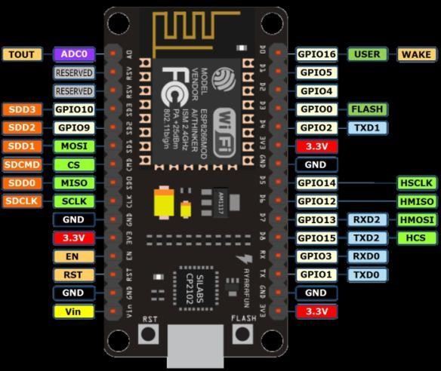

Esp8266 module

## VOC sensor

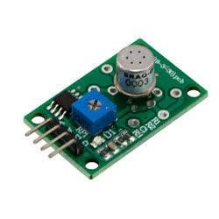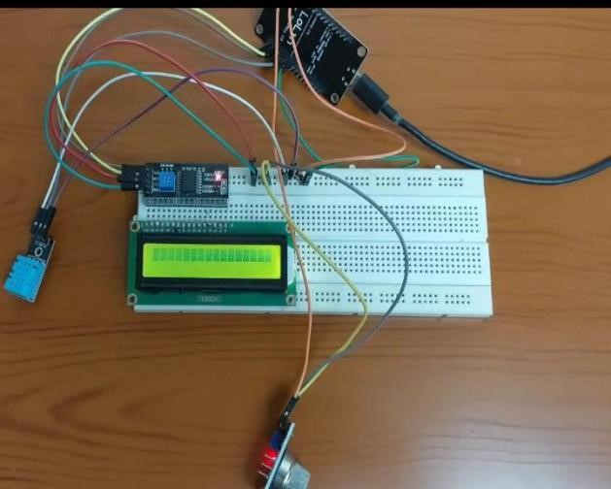

**3.DATA SHARING PLATFORM**:

To design a web-based platform to display real-time air quality data to the public, we need to consider the following aspects:

* The data sources and formats.

We need to decide what kind of air quality data we want to display, such as pollutant concentrations, air quality index, health effects, etc.

We also need to choose the data sources that provide reliable and timely data, such as satellite observations, ground-based measurements, numerical models, etc.

We need to ensure that the data formats are compatible and standardized, such as JSON, XML, CSV, etc.

* The data processing and storage.

We need to design a backend system that can collect, validate, transform, and store the data from different sources.

We also need to implement methods for data quality control, data analysis, data aggregation, and data visualization.

We need to choose a suitable database system that can handle large volumes of data and support fast queries and updates, such as MongoDB, PostgreSQL, etc.

* The data presentation and interaction.

We need to design a frontend system that can display the data in an intuitive and attractive way.

We also need to provide features for user interaction, such as filtering, searching, zooming, panning, etc.

We need to choose a suitable web framework and library that can support dynamic and interactive web pages, such as React, Angular, D3.js, etc.

One example of a web-based platform that provides access to air quality data is the Air Quality Data Mapping Tool developed by NASA-JPL. It uses satellite data products related to air quality, such as aerosol optical depth, nitrogen dioxide, and sulfur dioxide. It allows users to view and download data, as well as create custom visualizations and maps for analysis and research.

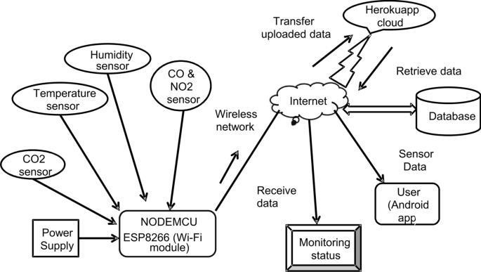

**4.INTEGRATION APPROACH:**

To determine how IoT devices will send data to the data-sharing platform, we need to consider the following aspects:

➢ The communication protocol.

We need to choose a suitable communication protocol that can enable the IoT devices to exchange data with the data-sharing platform. The protocol should be compatible with the device hardware and software, as well as the platform architecture and requirements. Some of the common communication protocols for IoT are MQTT, UDP, HTTP, CoAP, etc. Each protocol has its own advantages and disadvantages in terms of reliability, scalability, security, bandwidth, latency, etc.

For example, MQTT is a lightweight and publish-subscribe protocol that can support low-power and intermittent connectivity devices.

UDP is a fast and simple protocol that can support real-time streaming of data.

HTTP is a widely used and standardized protocol that can support RESTful APIs and web services. CoAP is a constrained application protocol that can support resource-oriented interactions and web transfer protocols .

* The data format.

We need to choose a suitable data format that can enable the IoT devices to encode and decode the data that they send and receive.

The data format should be consistent and standardized across the devices and the platform, as well as easy to parse and process.

Some of the common data formats for IoT are JSON, XML, CSV, etc. Each data format has its own advantages and disadvantages in terms of readability, compactness, flexibility, compatibility, etc.

For example, JSON is a human-readable and lightweight data format that can support hierarchical and nested structures. XML is a markup language that can support metadata and validation schemas. CSV is a simple and flat data format that can support tabular and numerical data .

* The data quality.

We need to ensure that the data that the IoT devices send to the data-sharing platform is accurate, complete, consistent, and timely.

Some of the factors that can affect the data quality are device calibration, sensor noise, network latency, data loss, data duplication, etc.

We need to implement methods for data quality control, such as data validation, filtering, cleaning, deduplication, etc., at both the device level and the platform level .